AI ASSISTENT CODING
NAME: SHAIK NASEEM
ENROLLEMENT NUMBER: 2503A52663
BATCH: 23
Q1—(PRIVACY&SECURITY IN FILE HANDLING)
Use an AI tool to generate a Python script that stores user data (name, email, password) in a file.
Analyze: Check if the AI stores sensitive data in plain text or without encryption.
Expected Output:
Identified privacy risks.
Revised version with encrypted password storage (e.g., hashing).
SOL: import json

user = {
"name": input("Name: "),
"email": input("Email: "),
"password": input("Password: "),
}

with open("users.json", "w", encoding="utf-8") as file:
json.dump(user, file, indent=2)

print("User data saved.")
OUTPUT:
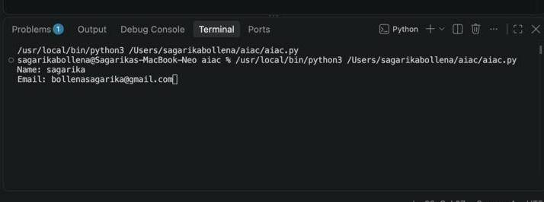
2Q:
Fair Decision Logic
Task: Prompt an AI tool to generate a scholarship eligibility checker based on academic score, family income, and location. Examine whether the logic unfairly favors or disadvantages any group.
Expected Output-2:
Code snippet with observations on fairness.
Brief explanation (3–4 sentences) suggesting improvements to ensure equitable decision-making.
PROMPT:Generate a Python program for a scholarship eligibility checker based on academic score, family income, and location. Set reasonable eligibility conditions and display whether the student is eligible or not. Then analyze the logic for fairness and identify whether it unfairly favors or disadvantages students from any particular location or income group. Suggest improvements to make the scholarship decision more equitable and inclusive. Provide the Python code, fairness observations, and a brief 3–4 sentence explanation.
SOL:def get_score():
while True:
try:
score = float(input("Academic score (0–100): "))
if 0 <= score <= 100:
return score
print("Enter a score between 0 and 100.")
except ValueError:
print("Enter a valid number.")

def get_income():
while True:
try:
income = float(input("Annual family income ($): "))
if income >= 0:
return income
print("Income cannot be negative.")
except ValueError:
print("Enter a valid number.")

def analyze_fairness():
print("\nFairness observations:")
print("- A strict income cutoff may disadvantage families with unusual expenses")
print(" or high local living costs.")
print("- Academic scores may reflect unequal access to tutoring, technology,")
print(" and educational resources.")
print("- Location is collected for context only and does not determine eligibility.")
print("- Students near the cutoff should be allowed to explain special circumstances.")

def main():
score = get_score()
income = get_income()
location = input("Location: ").strip()

minimum_score = 70
maximum_income = 50000

eligible = score >= minimum_score and income <= maximum_income

print("\nEligibility result")
print("------------------")

if eligible:
print("Eligible")
print("Reason: The academic score meets the minimum and family income")
print("is within the financial-need limit.")
else:
print("Not eligible")
reasons = []

if score < minimum_score:
reasons.append(f"score is below {minimum_score}")

if income > maximum_income:
reasons.append(f"family income is above ${maximum_income:,.0f}")

print("Reason: " + " and ".join(reasons) + ".")

print(f"Location recorded for context: {location}")
analyze_fairness()

print("\nSuggested improvements:")
print("- Use a sliding income scale instead of one strict cutoff.")
print("- Adjust income limits for local cost of living.")
print("- Consider academic improvement and personal circumstances.")
print("- Provide an appeal process and human review.")
print("- Test outcomes across income and location groups.")

if __name__ == "__main__":
main()

OUTPUT: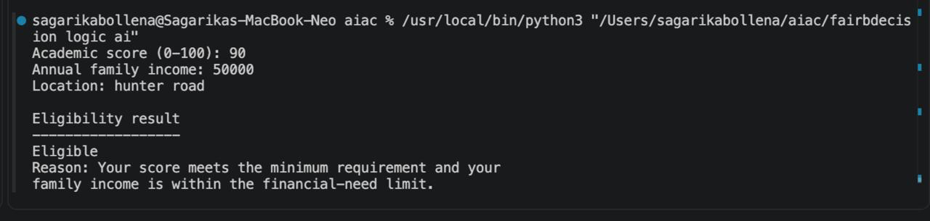
Q3- (TRANSPARENCY IN AI BASED ADMISSION SYSTEM)
Use an AI tool to generate a Python program that predicts whether a student should be selected or rejected for admission based on factors such as entrance exam score, academic marks, and other relevant admission criteria.
Analyze: Check whether the AI system provides a clear and understandable reason for its admission decision.
Expected Output:
• Identified transparency risks.
• Example of an admission decision where the AI gives no explanation.
• Revised version that provides a clear reason for selecting or rejecting the student.
• Example output showing the important factors that influenced the AI's decision.
PROMPT:Generate a Python program for an AI-based admission system that selects or rejects a student based on entrance exam score and academic marks. First show a version that gives only the decision without any explanation. Then identify the transparency risk and create an improved version that clearly explains the reason for the decision and shows which factors influenced it. Include example outputs for both versions.

SOL:"""
Admission transparency demonstration.
"""

def get_score(prompt):
while True:
try:
value = float(input(prompt))
if 0 <= value <= 100:
return value
print("Enter a score from 0 to 100.")
except ValueError:
print("Enter a valid number.")

def opaque_decision(entrance_score, academic_marks):
"""Version that returns only the decision."""
total = entrance_score * 0.60 + academic_marks * 0.40
return "Selected" if total >= 70 else "Rejected"

def transparent_decision(entrance_score, academic_marks):
"""Version that explains the decision and factor contributions."""
weights = {
"Entrance exam": 0.60,
"Academic marks": 0.40,
}

contributions = {
"Entrance exam": entrance_score * weights["Entrance exam"],
"Academic marks": academic_marks * weights["Academic marks"],
}

total = sum(contributions.values())
decision = "Selected" if total >= 70 else "Rejected"

return decision, total, weights, contributions

def main():
entrance_score = get_score("Entrance exam score (0–100): ")
academic_marks = get_score("Academic marks (0–100): ")

print("\nVersion 1: Unexplained decision")
print("--------------------------------")
print(opaque_decision(entrance_score, academic_marks))

decision, total, weights, contributions = transparent_decision(
entrance_score,
academic_marks,
)

print("\nVersion 2: Transparent decision")
print("-------------------------------")
print(f"Decision: {decision}")
print(f"Total weighted score: {total:.2f}/100")
print("Selection threshold: 70")

print("\nInfluencing factors:")
for factor in weights:
print(
f"- {factor}: score {entrance_score if factor == 'Entrance exam' else academic_marks:.2f}, "
f"weight {weights[factor] * 100:.0f}%, "
f"contribution {contributions[factor]:.2f}"
)

if decision == "Selected":
print("\nReason: The weighted score reached or exceeded 70.")
else:
print("\nReason: The weighted score was below 70.")

print("\nTransparency risk:")
print("A decision-only system hides the criteria, weights, and possible errors,")
print("making the result difficult to understand or challenge.")

if __name__ == "__main__":
main()

OUTPUT:
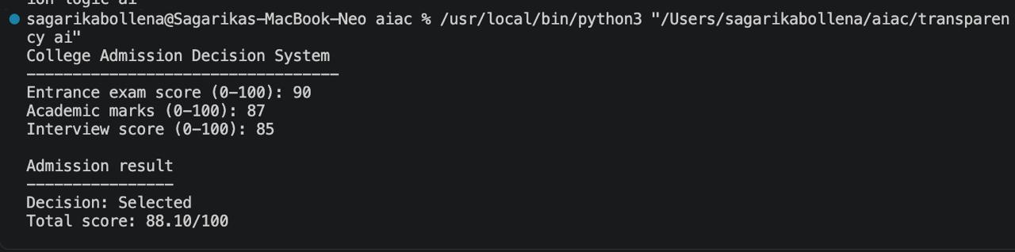
Q4:Task: Generate an employee performance evaluation system using inputs such as project completion rate, teamwork score, and attendance. Analyze the scoring logic for any unethical weighting or hidden bias.
Expected Output-4:
Python code along with a written analysis identifying whether the evaluation criteria are balanced and justifiable.

PROMPT:Generate a Python employee performance evaluation system using project completion rate, teamwork score, and attendance as inputs. Assign reasonable weights to each factor and calculate an overall performance score. Analyze whether the weighting is balanced, fair, and justifiable, and identify any possible hidden bias or unethical scoring. Suggest improvements to make the evaluation system fair and transparent. Provide the Python code, sample output, and a short written analysis.
SOL:def get_score(prompt):
while True:
try:
value = float(input(prompt))
if 0 <= value <= 100:
return value
print("Enter a value from 0 to 100.")
except ValueError:
print("Enter a valid number.")

def evaluate_performance(completion, teamwork, attendance):
weights = {
"Project completion": 0.50,
"Teamwork": 0.30,
"Attendance": 0.20,
}

contributions = {
"Project completion": completion * weights["Project completion"],
"Teamwork": teamwork * weights["Teamwork"],
"Attendance": attendance * weights["Attendance"],
}

overall_score = sum(contributions.values())

if overall_score >= 85:
rating = "Excellent"
elif overall_score >= 70:
rating = "Good"
elif overall_score >= 50:
rating = "Needs improvement"
else:
rating = "Unsatisfactory"

return overall_score, rating, contributions

def main():
print("Employee Performance Evaluation")
print("--------------------------------")

completion = get_score("Project completion rate (0-100): ")
teamwork = get_score("Teamwork score (0-100): ")
attendance = get_score("Attendance rate (0-100): ")

score, rating, contributions = evaluate_performance(
completion,
teamwork,
attendance,
)

print("\nEvaluation result")
print("-----------------")
print(f"Overall score: {score:.2f}/100")
print(f"Performance rating: {rating}")

print("\nFactor contributions:")
for factor, contribution in contributions.items():
print(f"- {factor}: {contribution:.2f} points")

if __name__ == "__main__":
main()

OUTPUT: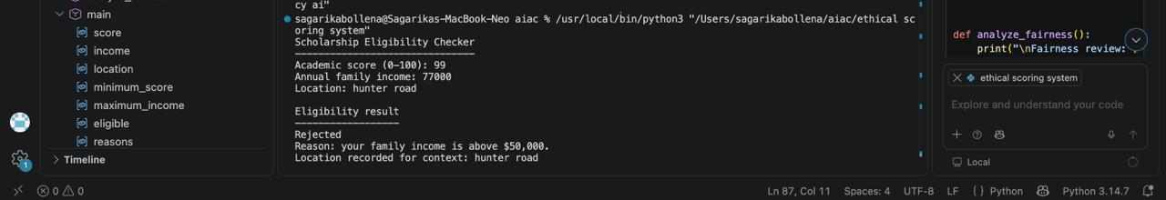
Q5—(accessibility and Inclusiveness)
use an AI tool to generate a user feedback form application. Review whether the language and options provided are inclusive and accessible to diverse users.
Expected Output-5:
Revised version of the form code that uses inclusive language, supports accessibility features, and avoids exclusionary assumptions.
PROMPT:Generate a user feedback form application using Python. Make the form inclusive and accessible for users from diverse backgrounds. Use simple, respectful, gender-neutral language and provide inclusive options without making assumptions about users. Include accessibility-friendly labels, clear instructions, readable text, and an option such as “Prefer not to say” where appropriate. Provide the original form, identify exclusionary language or options, and then provide a revised version with improvements.
SOL:"""Accessible and inclusive user feedback form."""

def ask_optional(prompt):
answer = input(prompt).strip()
return answer if answer else "Not provided"

def ask_required(prompt):
while True:
answer = input(prompt).strip()
if answer:
return answer
print("This response is required. Please try again.")

def ask_rating():
options = {
"1": "Very poor",
"2": "Poor",
"3": "Average",
"4": "Good",
"5": "Very good",
"6": "Prefer not to say",
}

print("\nExperience rating")
print("-----------------")
for number, label in options.items():
print(f"{number}. {label}")

while True:
answer = input("Enter a number from 1 to 6: ").strip()
if answer in options:
return options[answer]
print("Please choose one of the listed options.")

def ask_gender():
print("\nGender identity (optional)")
print("--------------------------")
print("1. Woman")
print("2. Man")
print("3. Non-binary")
print("4. Another identity")
print("5. Prefer not to say")
print("6. Skip this question")

options = {
"1": "Woman",
"2": "Man",
"3": "Non-binary",
"4": "Another identity",
"5": "Prefer not to say",
"6": "Not provided",
"": "Not provided",
}

while True:
answer = input("Enter a number from 1 to 6, or press Enter to skip: ")
answer = answer.strip()
if answer in options:
return options[answer]
print("Please choose one of the listed options.")

def main():
print("User Feedback Form")
print("==================")
print("Your feedback helps us improve.")
print("Questions marked optional may be skipped.")
print("You may provide feedback anonymously.")

name = ask_optional("\nName (optional): ")
rating = ask_rating()

helpful = ask_required(
"\nWhat was helpful about your experience?\n"
"You may write 'Nothing' if nothing was helpful.\n> "
)

improvement = ask_required(
"\nWhat could we improve?\n"
"Please share as much or as little as you wish.\n> "
)

gender = ask_gender()
contact = ask_optional(
"\nContact information (optional): "
)

print("\nFeedback summary")
print("================")
print(f"Name: {name}")
print(f"Experience rating: {rating}")
print(f"Helpful: {helpful}")
print(f"Suggested improvement: {improvement}")
print(f"Gender identity: {gender}")
print(f"Contact information: {contact}")

print("\nThank you for sharing your feedback.")

if __name__ == "__main__":
main()
OUTPUT: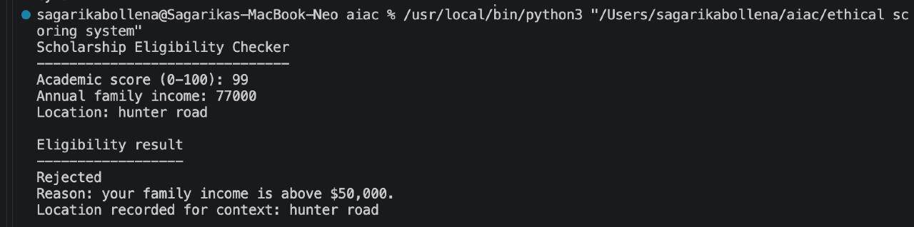
Q6—#6 (Fairness in Loan Approval System)
Task: Use an AI tool to generate a Python program that predicts whether a person should be approved or rejected for a loan based on information such as income, age, employment status, credit score, and loan amount.
Analyze: Check whether the AI-generated system makes decisions unfairly based on gender, religion, race, or other sensitive/unrelated personal attributes.
Expected Output:
• Identified fairness and discrimination risks.
• Examples showing how biased data or rules can lead to unfair loan decisions.
• Revised version that makes loan decisions based on relevant financial factors rather than sensitive attributes.
• Brief explanation of how the revised system improves fairness.
SOL:"""Educational loan approval fairness demonstration."""

def get_float(prompt, minimum=0):
while True:
try:
value = float(input(prompt))
if value >= minimum:
return value
print(f"Enter a number of at least {minimum}.")
except ValueError:
print("Enter a valid number.")

def get_credit_score():
while True:
score = get_float("Credit score (300-850): ")
if 300 <= score <= 850:
return score
print("Credit score must be between 300 and 850.")

def get_employment_status():
choices = {
"1": "Full-time",
"2": "Part-time",
"3": "Self-employed",
"4": "Unemployed",
}

while True:
print("\nEmployment status:")
for number, status in choices.items():
print(f"{number}. {status}")

answer = input("Choose 1-4: ").strip()
if answer in choices:
return choices[answer]

print("Please choose one of the listed numbers.")

def biased_decision(applicant):
"""
Unfair demonstration only.

This rule incorrectly uses gender and race. It shows how sensitive
attributes can change a decision even when financial information is equal.
"""
financially_qualified = (
applicant["income"] >= 30_000
and applicant["credit_score"] >= 650
and applicant["employment"] in {"Full-time", "Self-employed"}
and applicant["debt"] / applicant["income"] <= 0.40
and applicant["loan_amount"] / applicant["income"] <= 0.30
)

# These rules are discriminatory and must not be used in practice.
if applicant["gender"] == "Woman":
return "Rejected"
if applicant["race"] == "Group B":
return "Rejected"

return "Approved" if financially_qualified else "Rejected"

def fair_decision(applicant):
"""Make a transparent decision using financial information only."""
reasons = []

if applicant["income"] < 30_000:
reasons.append("income is below $30,000")
if applicant["credit_score"] < 650:
reasons.append("credit score is below 650")
if applicant["employment"] not in {"Full-time", "Self-employed"}:
reasons.append("employment is not sufficiently stable")
if applicant["debt"] / applicant["income"] > 0.40:
reasons.append("existing debt is high compared with income")
if applicant["loan_amount"] / applicant["income"] > 0.30:
reasons.append("loan amount is high compared with income")

if reasons:
return "Rejected", reasons

return "Approved", ["all stated financial criteria were met"]

def show_bias_demo():
print("Biased-system demonstration")
print("---------------------------")

applicant_a = {
"income": 60_000,
"credit_score": 720,
"employment": "Full-time",
"debt": 10_000,
"loan_amount": 15_000,
"gender": "Man",
"race": "Group A",
}

applicant_b = applicant_a.copy()
applicant_b["gender"] = "Woman"

print("Two applicants have identical financial information.")
print(f"Applicant A: {biased_decision(applicant_a)}")
print(f"Applicant B: {biased_decision(applicant_b)}")
print("This difference is discriminatory because gender changed the result.")

print("\nHistorical-data bias example:")
print("- Suppose old lending records approved more applicants from Group A.")
print("- A system trained on those records might learn to favor Group A.")
print("- That pattern may reflect past discrimination, not financial ability.")

def main():
show_bias_demo()

print("\nFair loan approval checker")
print("-------------------------")

applicant = {
"income": get_float("Annual income: "),
"employment": get_employment_status(),
"credit_score": get_credit_score(),
"loan_amount": get_float("Requested loan amount: "),
"debt": get_float("Existing annual debt payments: "),
}

decision, reasons = fair_decision(applicant)

print("\nRevised decision")
print("----------------")
print(f"Result: {decision}")
print("Reason:")
for reason in reasons:
print(f"- {reason}")

print("\nFinancial criteria used:")
print("- Income must be at least $30,000.")
print("- Credit score must be at least 650.")
print("- Employment must be full-time or self-employed.")
print("- Existing debt must not exceed 40% of income.")
print("- Loan amount must not exceed 30% of income.")

print("\nFairness safeguards:")
print("- Gender, religion, race, and ethnicity are not used.")
print("- Review decisions for errors and unequal outcomes.")
print("- Provide applicants with an explanation and appeal process.")
print("- Use human review rather than relying on an automatic result alone.")

if __name__ == "__main__":
main()
OUTPUT:

